**A**

**Minor Project Report**

**on**

**“TIC TAC TOE GAME”**

**Submitted to**

**RAJIV GANDHI TECHNICAL UNIVERSITY BHOPAL (M.P)**



**In Partial fulfillment for the award of degree of**

**BACHELOR OF ENGINEERING**

**IN**

**COMPUTER SCIENCE & ENGINEERING**

**By**

MONIKA CHOUDHARY (0608CS201031)

ARYAN KESHARWANI (0608CS201008)

KSHITIJ SONI (0608CS201026)

SIDDHI NEMA(0608CS201059)



**BABULAL TARABAI INSTITUTE OF RESEARCH & TECHNOLOGY, SAGAR (BTIRT)**

**May-2022**

***DECLARATION***

We hereby declare that the project entitled “**TIC TAC TOE GAME ”** is the actual work carried out by us in the department of **COMPUTER SCIENCE & ENGINEERING**.

**Name Enrollment Number Signature**

MONIKA CHOUDHARY 0608CS201031

ARYAN KESHARWANI 0608CS201008

KSHITIJ SONI 0608CS201026

SIDDHI NEMA 0608CS201059

.

**CERTIFICATE**

This is to certify that the project entitled “TIC TAC TOE GAME” has been carried out by MONIKA CHOUDHARY (0608CS201031), ARYAN KESHARWANI (0608CS201008), KSHITIJ SONI (0608CS201026), SIDDHI NEMA (0608CS201059) under my guidance in partial fulfillment for the award of BACHELOR OF ENGINEERING in COMPUTER SCIENCE & ENGINEERING by the Rajiv Gandhi Technical University, Bhopal (M.P.), during the academic year 2022-2023.

Mrs. Anamika Pyasi

(Head Of Computer Science & Engineering Department)

**CERTIFICATE OF APPROVAL**

The Minor Project Report title entitled “**PROJECT NAME**” being submitted by MONIKA CHOUDHARY (0608CS201031), ARYAN KESHARWANI (0608CS201008), KSHITIJ SONI (0608CS201026), SIDDHI NEMA (0608CS201059) has been examined by us and is hereby approved for the award of degree “Bachelor of Engineering in CSE”, for which it has been submitted. It is understood by this approval that the undersigned do not necessarily endorse or approve any statement made, opinion expressed or conclusion drawn therein. Approval of the project only to the purpose for which it has been submitted.

**(Internal) (External)**

Date: Date:

**ACKNOWLEDGEMENT**

It gives me immense pleasure to express my deepest sense of gratitude. I also wish to express my gratitude’s to **Mrs. Anamika Pyasi, HOD, Computer Science & Engineering** for her kind hearted support.

I would like to express my sincere thanks to **Dr. Veeresh Fuskele, Principal, BTIRT, Sagar** for giving me this opportunity to undertake this project.

I also wish to express my indebtedness to my parents as well as my family member whose blessings and support always helped me to face the challenges ahead.

At the end I would like to express my sincere thanks to all my friends and others who helped me directly or indirectly during this dissertation work.

**Name Enrollment Number Signature**

MONIKA CHOUDHARY 0608CS201031

ARYAN KESHARWANI 0608CS201008

KSHITIJ SONI 0608CS201026

SIDDHI NEMA 0608CS201059

|  |  |  |
| --- | --- | --- |
| **INDEX** | | |
| **TITLE** |  | **PAGE NO.** |
|  | | |

* Introduction. 1
* Hardware and Software requirements. 2
* Functions. 3
* Header Files. 4
* Source Code. 5-8
* Game Interface. 9
* Limitations. 10
* Future Scope. 10
* Conclusion. 11
* References. 11

**INTRODUCTION**

* This game is very popular and is fairly simple by itself. It is actually a two player game . In this game , there is a board with n X n squares. In our game , it is 3 X 3 squares.
* The goal of Tic Tac Toe is to be one of the players to get three same symbols in a row horizontally , vertically or diagonally – on a 3 X 3 grid.
* In this game , players soon discover that best play from both the parties leads to a draw . Hence Tic –Tac – Toe is most often played by young children .

**HARDWARE & SOFTWARE REQUIREMENTS**

**Hardware Requirement :-**

* **Processor Required** :- Not Specified
* **OS** :- Windows/IOS
* **Minimum Storage Required** :- 2GB
* **Minimum Ram Required** :- 2GB

**Software Requirements :-**

* + **Visual Studio Code** (Latest Version 1.73.1
  + **MinGW Compiler**

**FUNCTIONS**

* **printInputMatrix( )** : this function prints the input matrix of 3 X 3 with having field’s name mentioned in that particular field.
* **printBoard( )** : this function prints the whole Tic – Tac – Toe grid of 3 X 3 .
* **addMark( )** : this function is used to add mark to particular fields chosen by the players .
* **check( )** : this function checks if any of the players has won the game or not , it is also used to check if the game is draw .

**HEADER FILES**

* **#include<iostream.h>** :  iostream stands for standard input-output stream. This header file contains definitions of objects like cin, cout, etc.
* **#include<conio.h>** : The conio stands for Console-Input-Output. The conio.h is a non-standard header file used in C and C++ programming. This file contains console input-output functions which are mostly used by MS-DOS compilers. This header file contains definitions of funtions like getch( ) , clrscr ( ) , etc .
* **using namespace std ;** :  a **namespace** is a collection of related names or identifiers (functions, class, variables) which helps to separate these identifiers from similar identifiers in other namespaces or the global namespace.

**SOURCE CODE**

#include <iostream>

#include <conio.h>

using namespace std;

void printInputMatrix();

void printBoard();

int addMark();

int check();

char board[3][3] = {' ',' ',' ',

                    ' ',' ',' ',

                    ' ',' ',' '};

int turn = 1; //1-Player 1 | 0-Player 2

char mark = 'O'; //O-Player 1 | X-Player 2

int input;

int main(){

    int won = 0;

    int validInput = 0;

    for(int i=0; i<9; i++){

        system("cls");

        printBoard();

        if(turn) cout<<"Player 1 Turn (Symbol: O)"<<endl;

        else cout<<"Player 2 Turn (Symbol: X)"<<endl;

        printInputMatrix();

        cout<<"Enter Input from Input Matrix: ";

        cin>>input;

        while(input<0 || input>9){

            cout<<"Invalid Input. Please Re-Enter input: ";

            cin>>input;

        }

        if(turn) mark = 'O';

        else mark = 'X';

        validInput = addMark();

        if( !validInput ){

            i--;

            continue;

        }

        won = check();

        if( won){

            system("cls");

            printBoard();

            if(turn) cout<<endl<<"!!!! Player 1 - Won !!!!";

            else cout<<endl<<"!!!! Player 2 -  Won !!!!";

            getch();

            break;

        }

        if(i==8){

            system("cls");

            printBoard();

            cout<<endl<<"!!!!  MATCH DRAW  !!!!";

        }

        turn = !turn;

    }

    return 0;

}

void printInputMatrix(){

    cout<<endl<<endl<<"INPUT MATRIX"<<endl;

    cout<<" 1 | 2 | 3 "<<endl;

    cout<<"------------"<<endl;

    cout<<" 4 | 5 | 6 "<<endl;

    cout<<"------------"<<endl;

    cout<<" 7 | 8 | 9 "<<endl;

}

void printBoard(){

    cout<<" "<<board[0][0]<<" | "<<board[0][1]<<" | "<<board[0][2]<<" "<<endl;

    cout<<"------------"<<endl;

    cout<<" "<<board[1][0]<<" | "<<board[1][1]<<" | "<<board[1][2]<<" "<<endl;

    cout<<"------------"<<endl;

    cout<<" "<<board[2][0]<<" | "<<board[2][1]<<" | "<<board[2][2]<<" "<<endl;

}

int addMark(){

    for(int i=0,k=1; i<3; i++ ){

        for(int j=0; j<3; j++,k++){

            if( k==input )

                if(board[i][j] == ' '){

                    board[i][j] = mark;

                    return 1;

                }

                else{

                    cout<<"Invalid Input";

                    getch();

                    return 0;

                }

        }

    }

}

int check(){

    //checking rows

    if(board[0][0]==mark && board[0][1]==mark && board[0][2]==mark)

        return 1;

    if(board[1][0]==mark && board[1][1]==mark && board[1][2]==mark)

        return 1;

    if(board[2][0]==mark && board[2][1]==mark && board[2][2]==mark)

        return 1;

    //checking Columns

    if(board[0][0]==mark && board[1][0]==mark && board[2][0]==mark)

        return 1;

    if(board[0][1]==mark && board[1][1]==mark && board[2][1]==mark)

        return 1;

    if(board[0][2]==mark && board[1][2]==mark && board[2][2]==mark)

        return 1;

    //checking diagonals

    if(board[0][0]==mark && board[1][1]==mark && board[2][2]==mark)

        return 1;

    if(board[0][2]==mark && board[1][1]==mark && board[2][0]==mark)

        return 1;

    return 0;

}

**----------------------------------END--------------------------------**

**GAME INTERFACE**

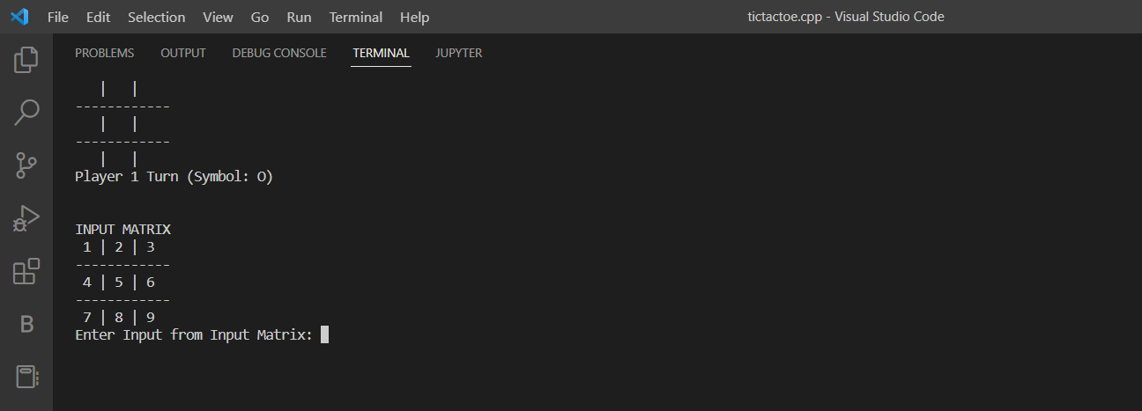

**IMAGE 1**

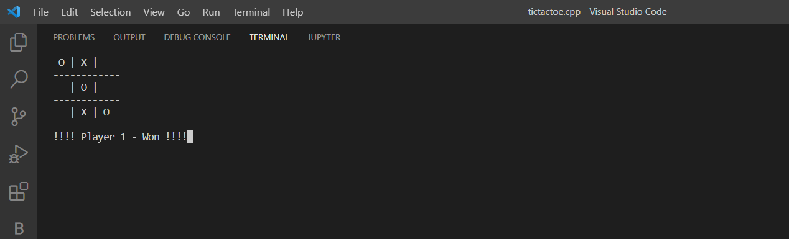

**IMAGE 2**

**LIMITATIONS**

* You can’t add graphics.
* This game can’t be played by more than two persons.
* It doesn’t contain level.

**FUTURE SCOPE**

Our project will be able to implement in future after making some changes and modifications as we make our project at a very low level . So the modifications that can be done in our project are :

* We can connect our program to SQL through which we can store the data of players who won the game multiple times.
* We can store the number of winning matches and drawn matches between the two players .

**CONCLUSION**

The Tic Tac Toe game is most familiar among all the age groups. Intelligence can be property of any purpose-driven decision maker . This basic idea has been suggested many times . An algorithm of playing Tic Tac Toe has been presented and tested that works in efficient way. Overall the system works without any bugs .

**REFERENCES**

* GeeksforGeeks : <https://www.geeksforgeeks.org/c-plus-plus/> .
* W3Schools : <https://www.w3schools.com/cpp/cpp_intro.asp> .
* Programiz : <https://www.programiz.com/cpp-programming> .